Customer Complaint/feedback management system

User Guide

Module
- Admin
- Customer
- Branch
- Primary
- Secondary
Two Types of Login
- Login
- OTP Login
Login
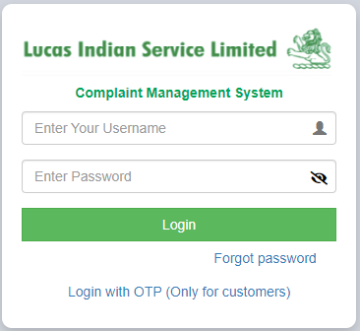
- Login for Customer, Branch, Primary contact, Secondary contact
- Username as <code>
OTP Login (Only for customer)
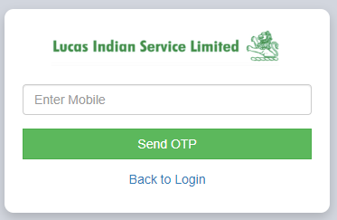
- Enter Customer Mobile No, Click on send OTP
- Enter the OTP to validate, once done Dashboard screen will appear
Forgot Password
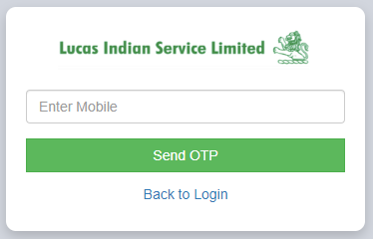
Customer Login
- Dashboard
- Register Complaint
- View Complaint
- Change Password
Dashboard
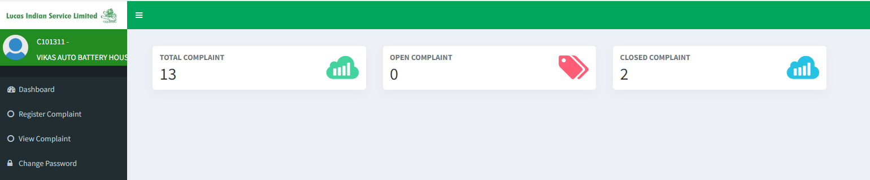
Register Complaint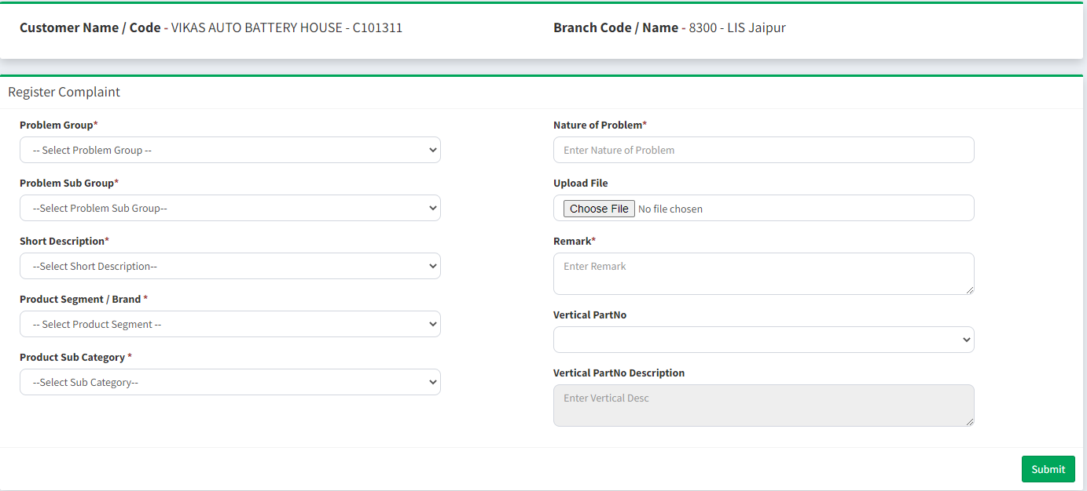
- Register complaint No Format – LIS - <custcode> - <Date> - 00001
View Complaints
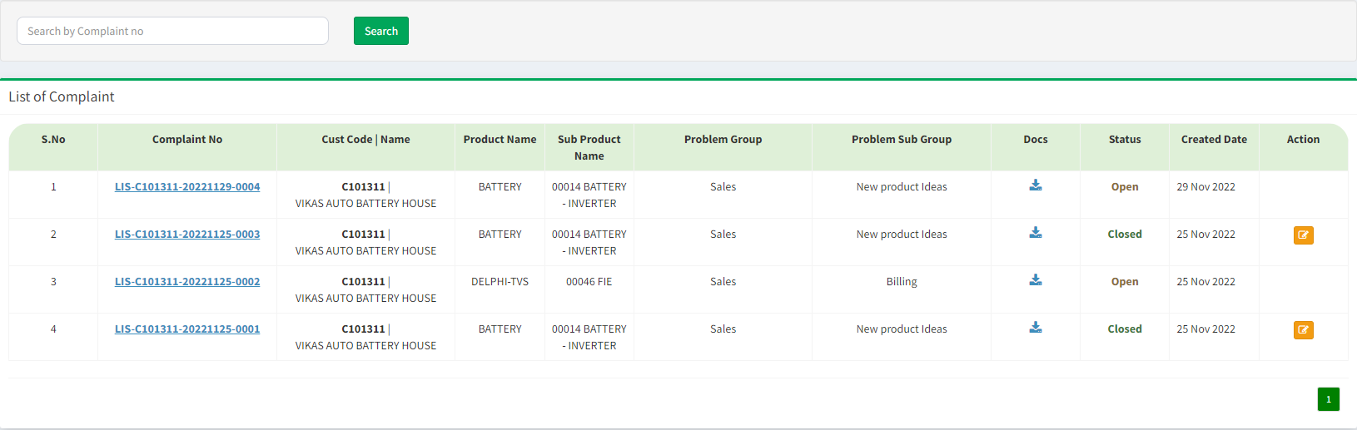
- Complaint status will be Open Edit button will be not show.
- Complaint status will be Closed Edit button will be show.
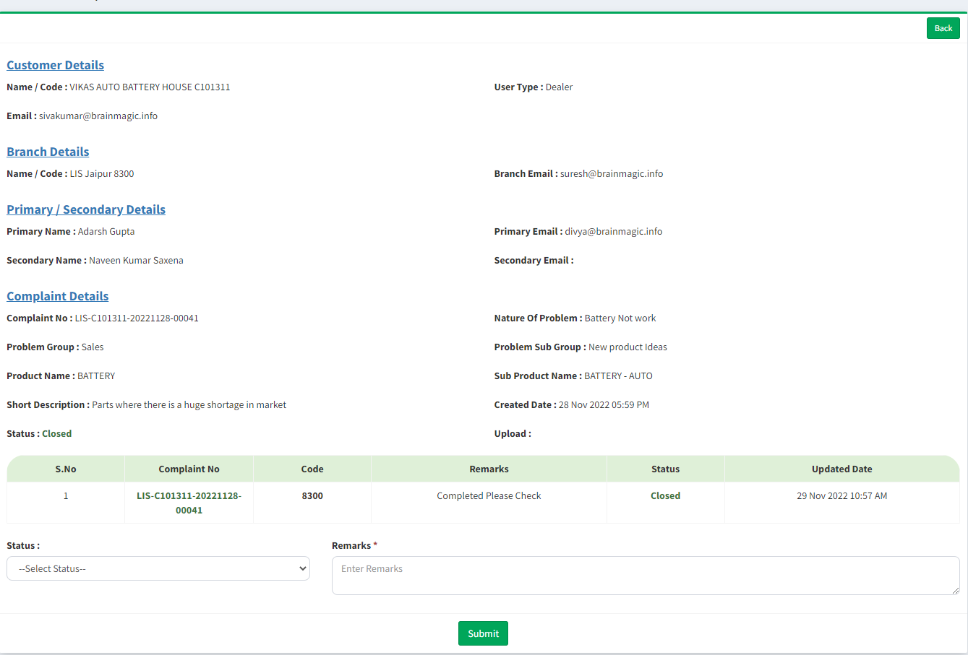

Branch Login
- Dashboard
- View Complaints
- Primary Complaints
- Copy Complaints
- Change Password
Dashboard
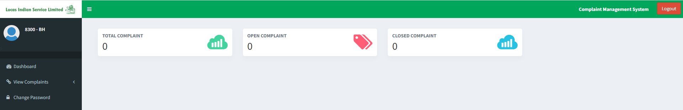

View Complaints
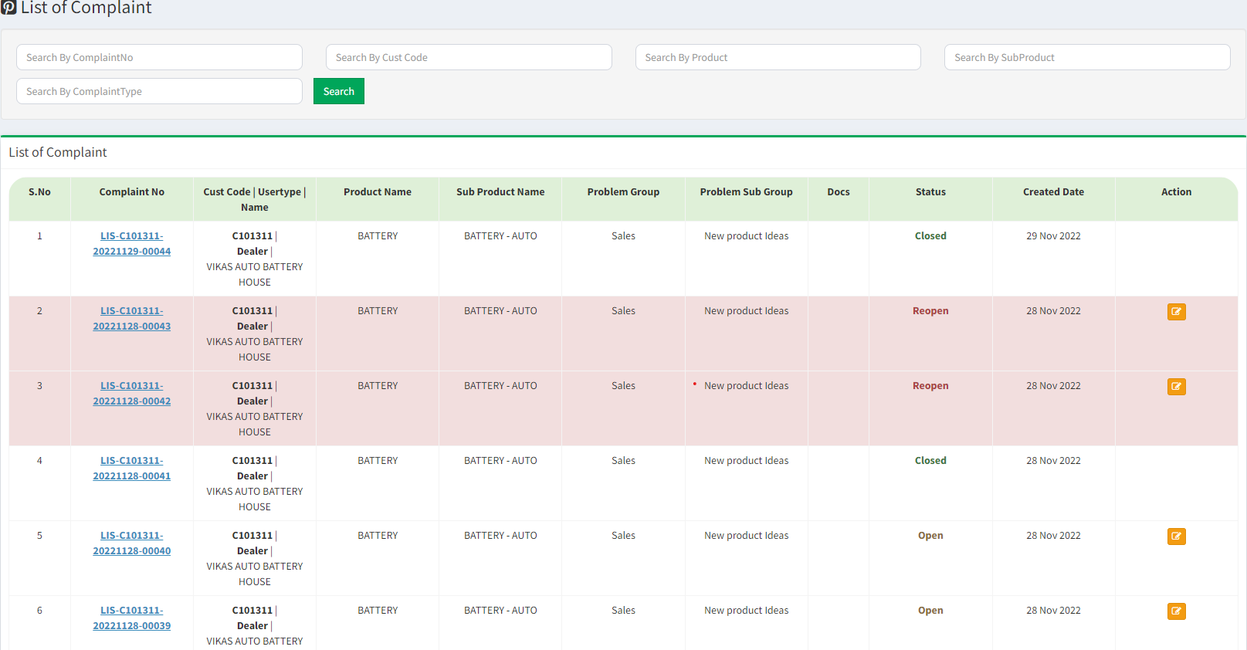

- Complaint status will be Open, Reopen Edit button will be show.
- Complaint status will be Closed Edit button will be not show.

User Click the Edit Button Show the below screen
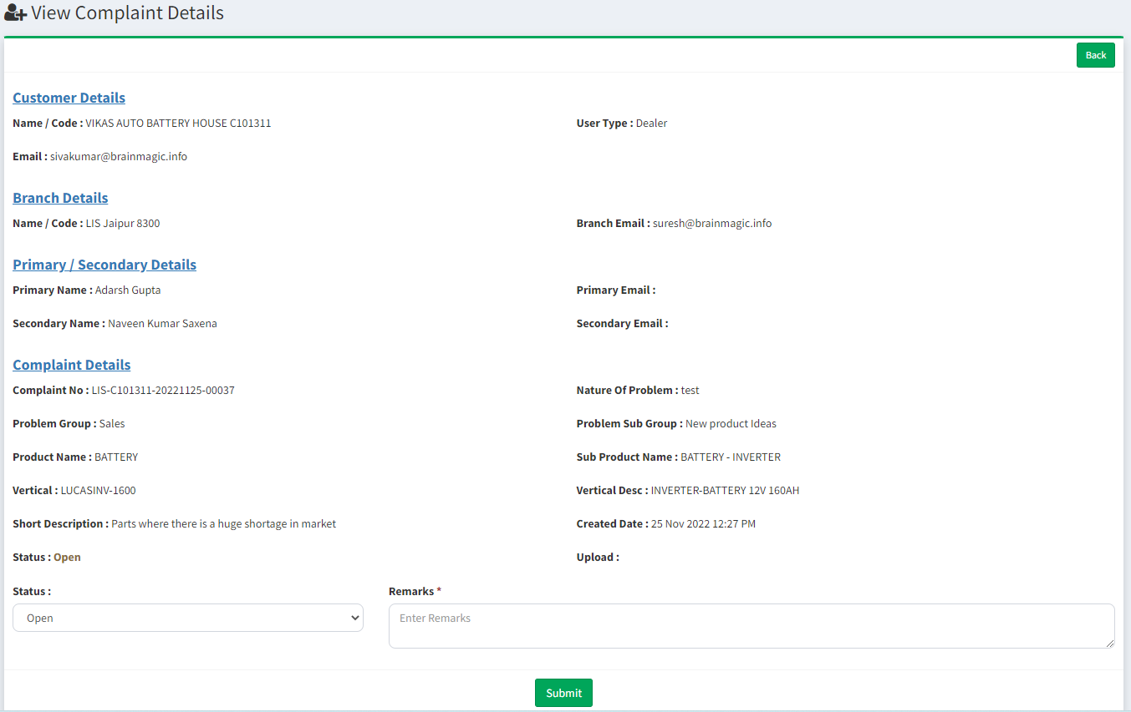
Admin Login
- Dashboard
- Master
- Products
- Product Sub Category
- Part Master
- Problem Group
- Problem Sub Group
- Branch
- Customer
- Short Description
- User Master
- Upload
- Import Part no
- Import Branch
- Import Customer
- Complaint Mapping
- View Complaint
- Change Password

Dashboard

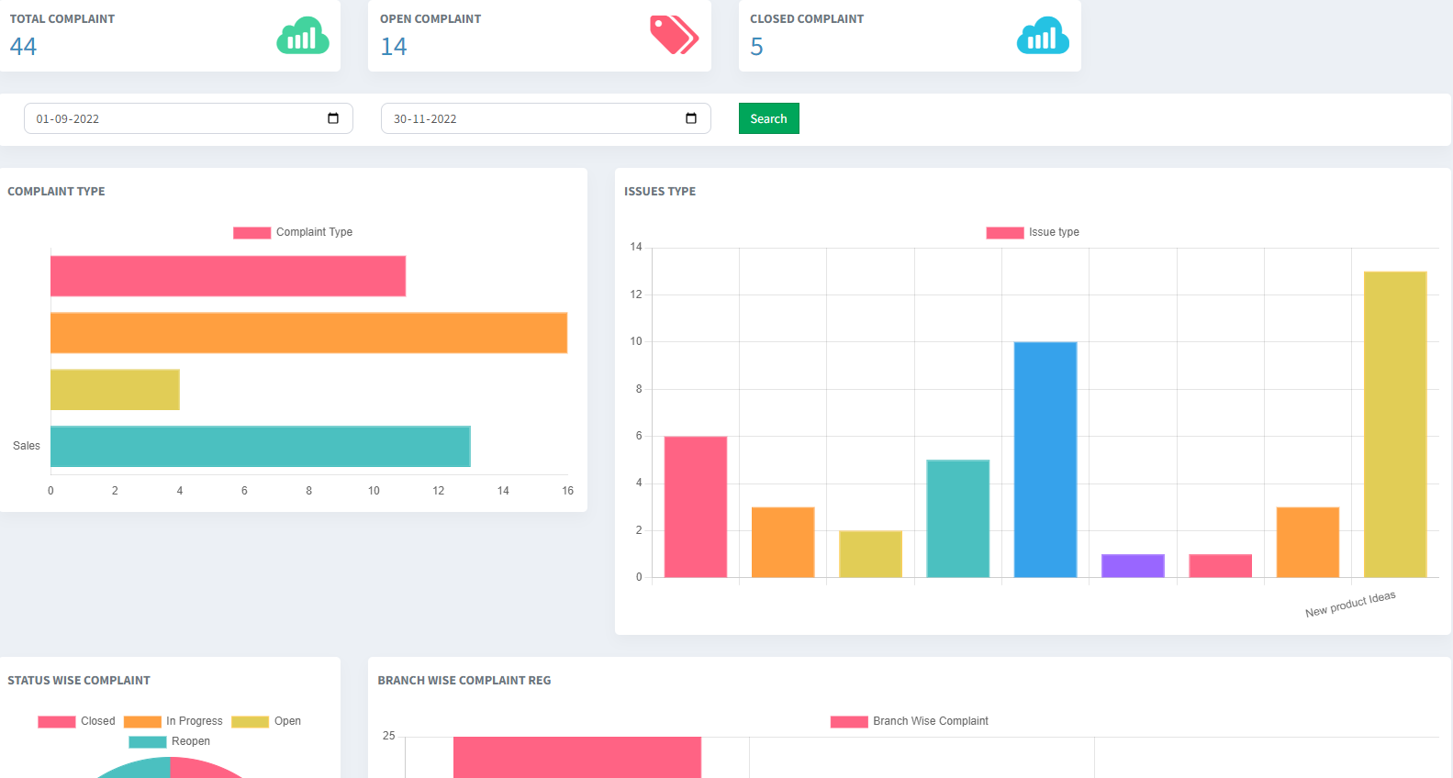

Masters
View Products
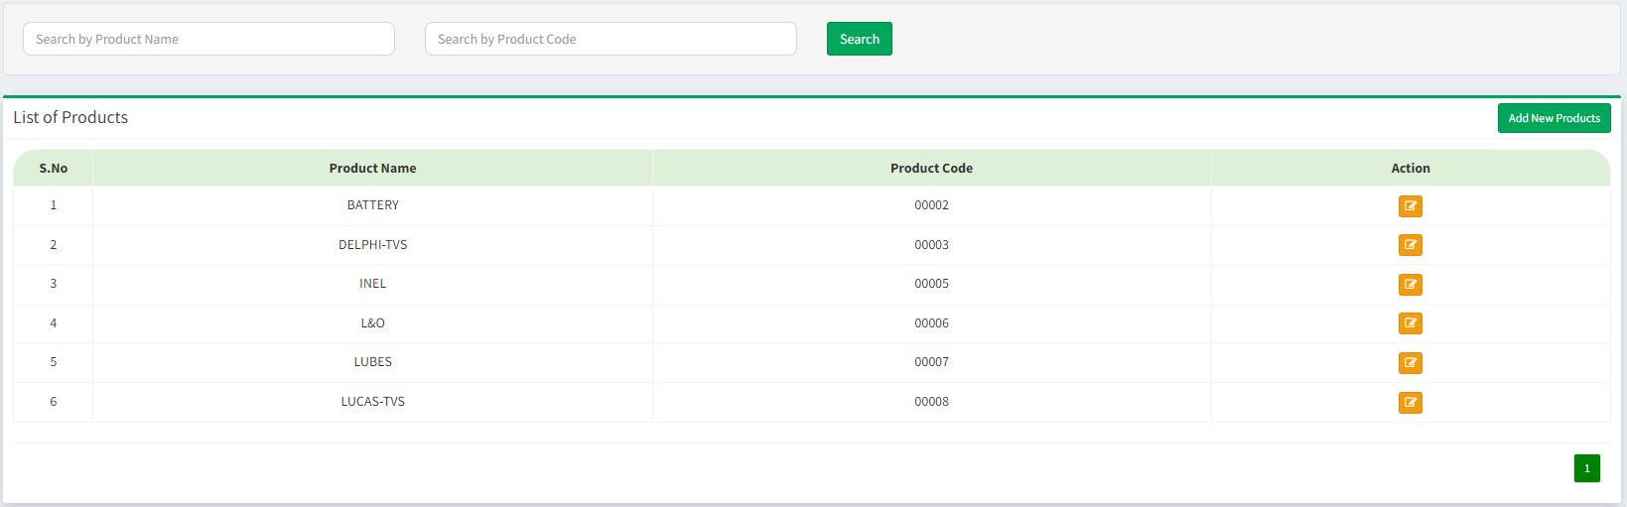
Add Products
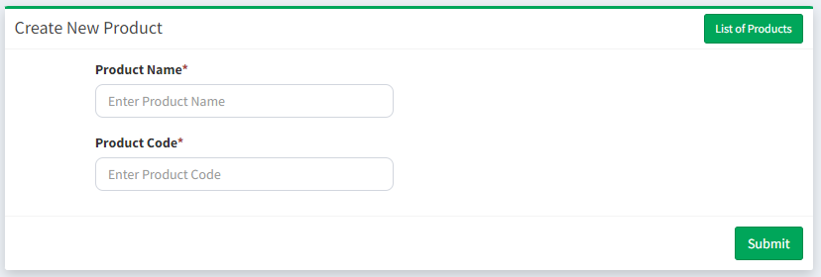

View Product Sub Category
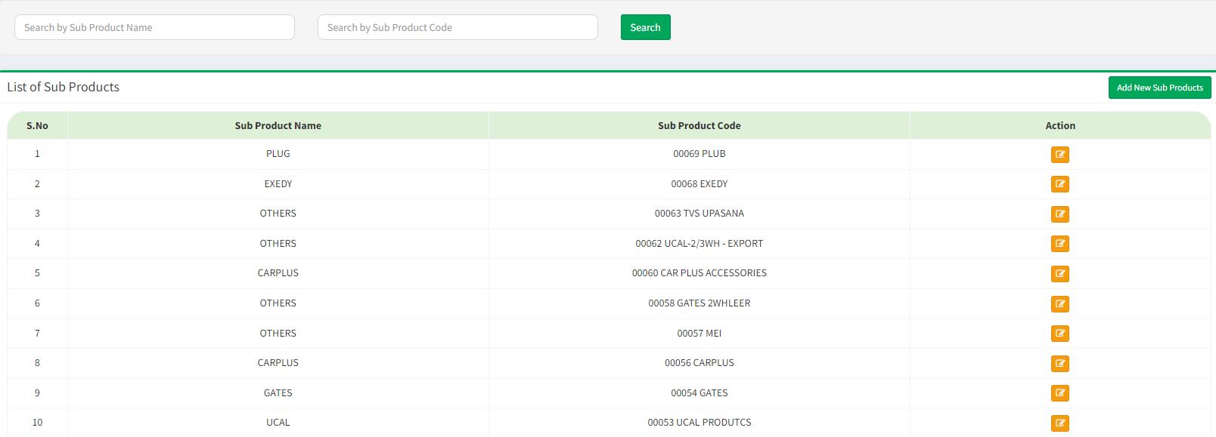

Add Product Sub Category
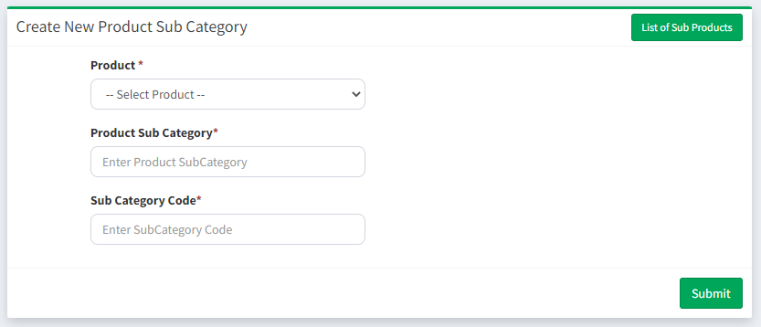
View Part Master
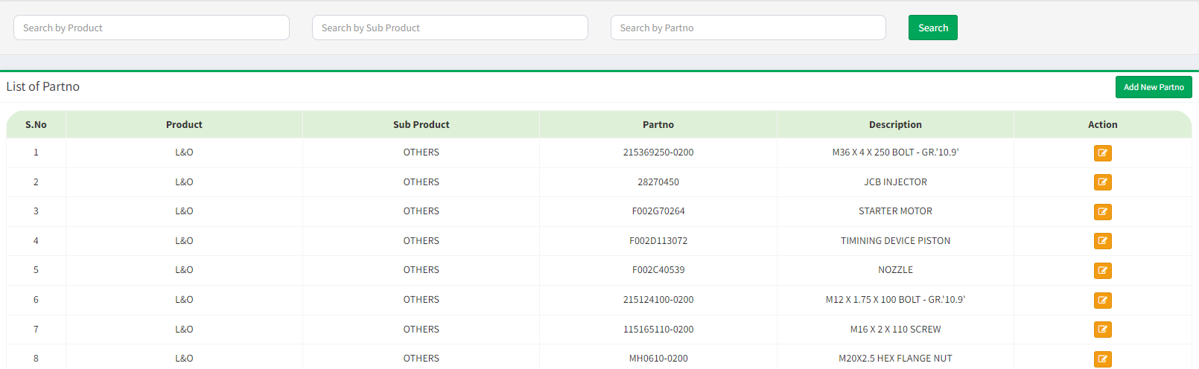
Create Part No
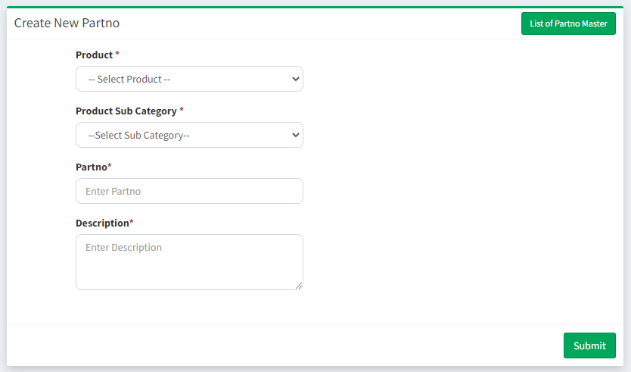

Problem Group
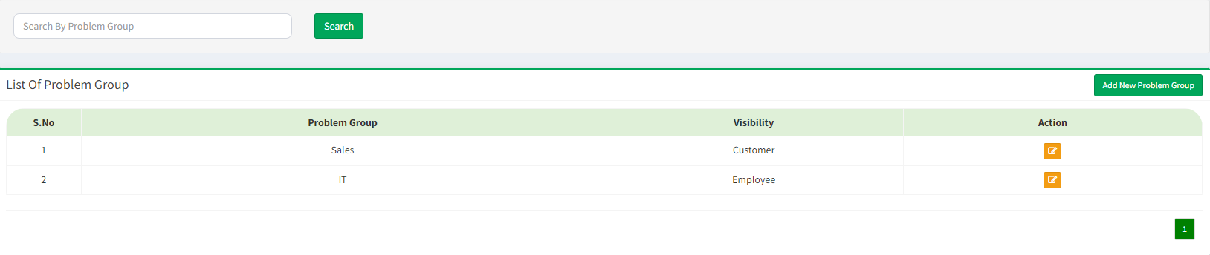
Create Problem Group
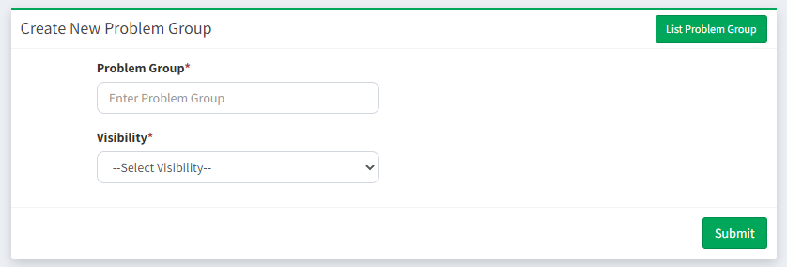

Problem Sub Group
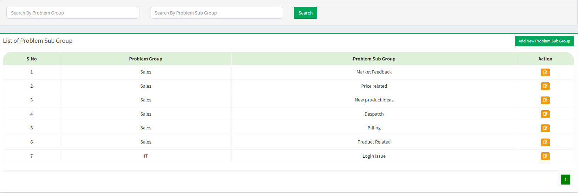

Created Problem Sub Group
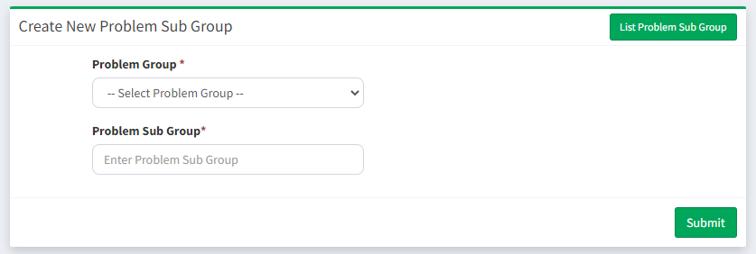
Branch
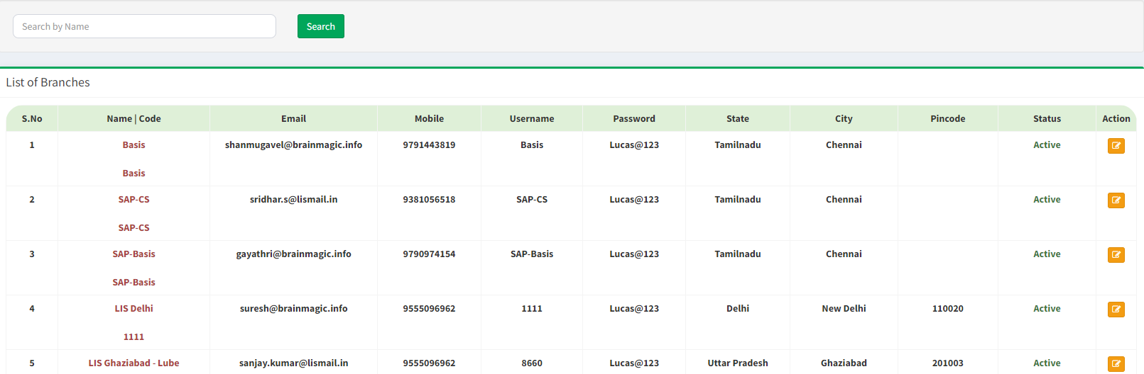

Customer
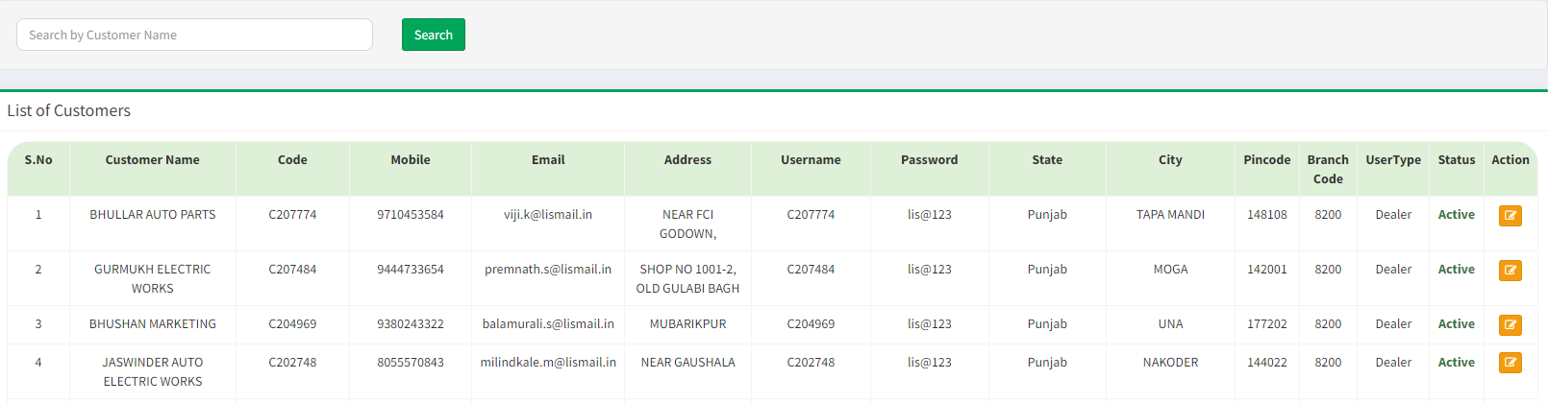

Short Description
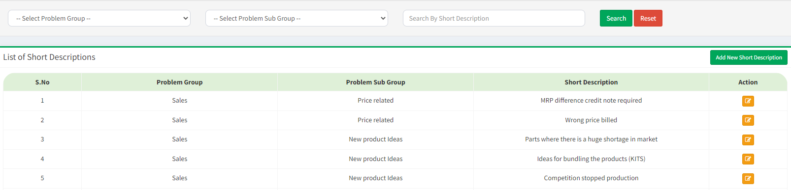
Create Short Description
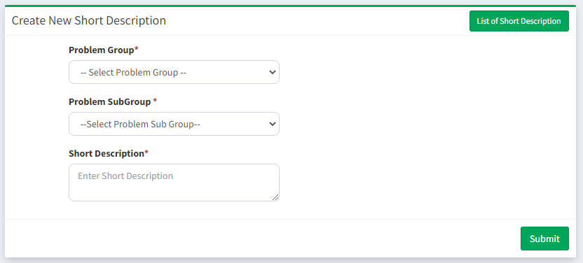
User Master
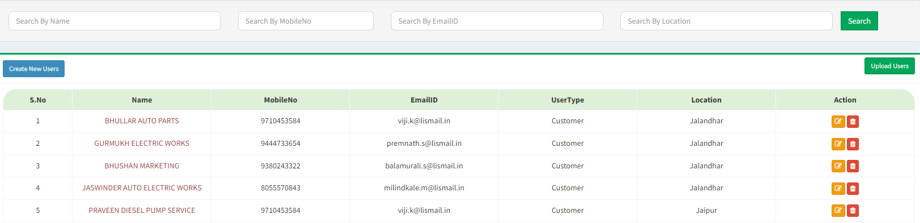
Upload User
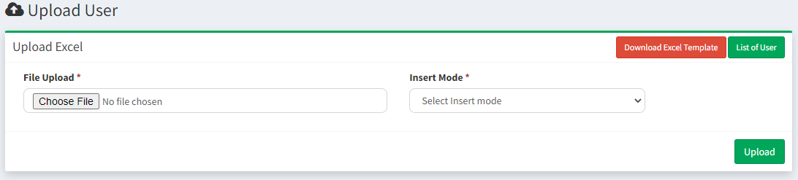
Upload
Import Part No
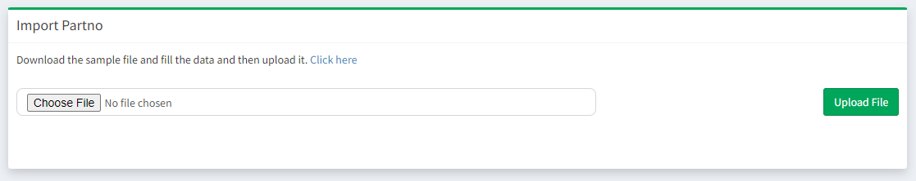

Import Branch
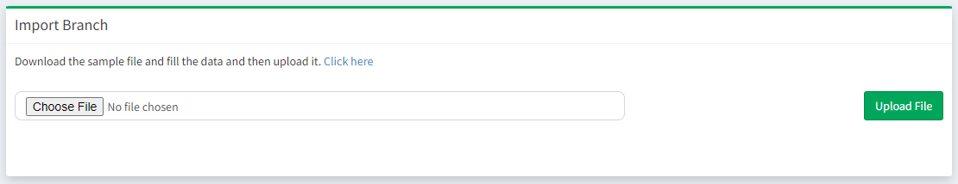

Import Customer
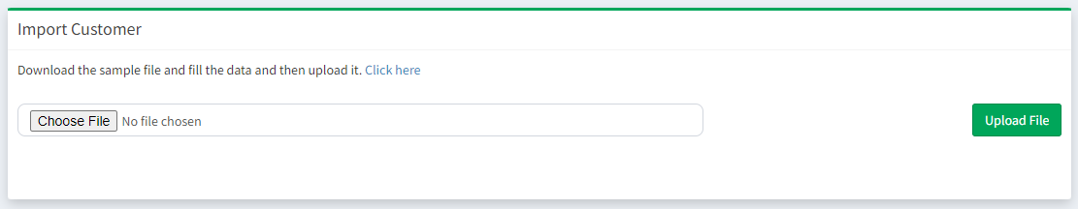
Complaint Mapping
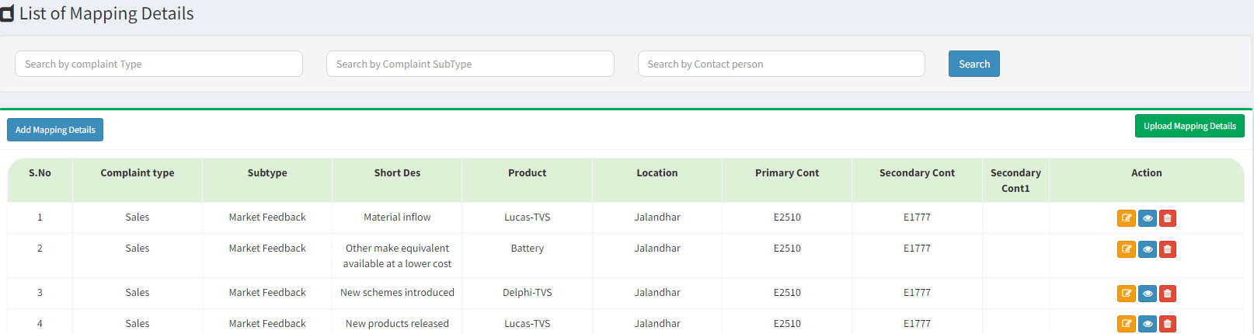
Upload Mapping
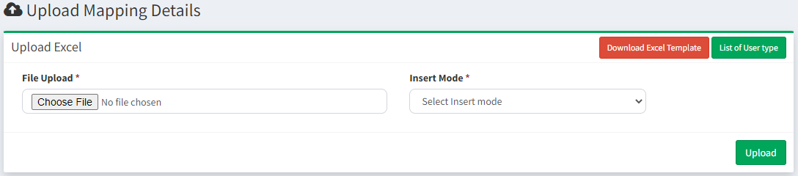
View Complaints
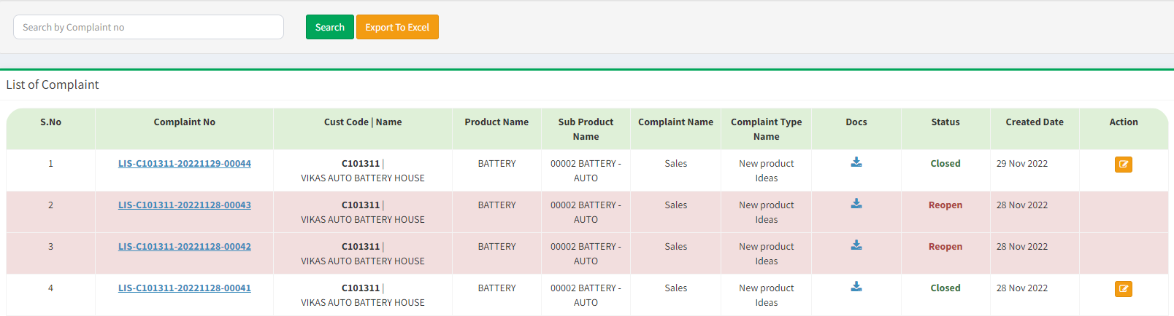
Mail/SMS working process
